

Bachelor of Computer Applications Semester – V
Deep Learning Project 3
Title: Comparison of Deep Learning Architectures

SubmittedBy:
Name:Bijjam Sharvani
Reg. No.: 2411021240060
Date: 31/08/2026

Submitted To: Faculty Name: Nagasri Mam

Department of Computer Application Alliance University
Chandapura - Anekal Main Road, Anekal Bengaluru – 562106

Project 3
Comparison of Deep Learning Architectures

Introduction

Deep Learning is an advanced area of Artificial Intelligence (AI) that enables computers to learn complex patterns from data using artificial neural networks. It is a specialized branch of Machine Learning in which multiple layers of interconnected neurons are used to process information and produce predictions or decisions.The main idea behind deep learning is inspired by the working of the human brain. Just as the brain processes information through interconnected neurons, a deep learning model processes information through layers of artificial neurons. Each layer learns different patterns from the input data. The earlier layers generally learn simple patterns, while deeper layers can learn more complex representations.

Deep Learning has become an important technology because it can work with large and complex datasets. It is capable of processing different forms of data, including images, text, audio, video, and numerical data. During the learning process, the model identifies relationships within the data and adjusts its internal parameters to improve its predictions.

A basic deep learning system consists of an input layer, hidden layers, and an output layer. The input layer receives the data, the hidden layers perform calculations and extract useful patterns, and the output layer provides the final result. The model learns by comparing its predicted output with the expected output. The error is calculated and the network parameters are adjusted repeatedly during training.

One of the major advantages of deep learning is its ability to perform automatic feature extraction. Instead of depending completely on manually selected features, deep learning models can learn useful characteristics directly from the available data. This makes them suitable for solving complicated problems where identifying relevant features manually can be difficult.

Different problems require different neural network architectures. For example, an architecture designed for numerical data may not be the best choice for an image, while a model suitable for images may not be ideal for a sequence of words. Therefore, selecting an appropriate architecture is an important part of developing a deep learning solution.

Deep Learning is widely used in many real-world applications such as image recognition, medical diagnosis, speech processing, recommendation systems, autonomous vehicles, fraud detection, natural language processing, and forecasting. Its ability to learn from large amounts of data has made it an important technology in modern AI systems.

This project focuses on understanding and comparing three important deep learning architectures: Feedforward Neural Networks (FNN), Convolutional Neural Networks (CNN), and Recurrent Neural Networks (RNN). These architectures differ in their structure, working mechanism, and the type of data they are designed to process. The project examines their basic architectures, applications, strengths, limitations, and differences.

- FNNs process static tabular data through fully connected layers
- CNNs exploit spatial grid hierarchies via parameter-sharing convolutional filters
- RNNs maintain temporal memory across sequential streams using recurrent feedback loops.

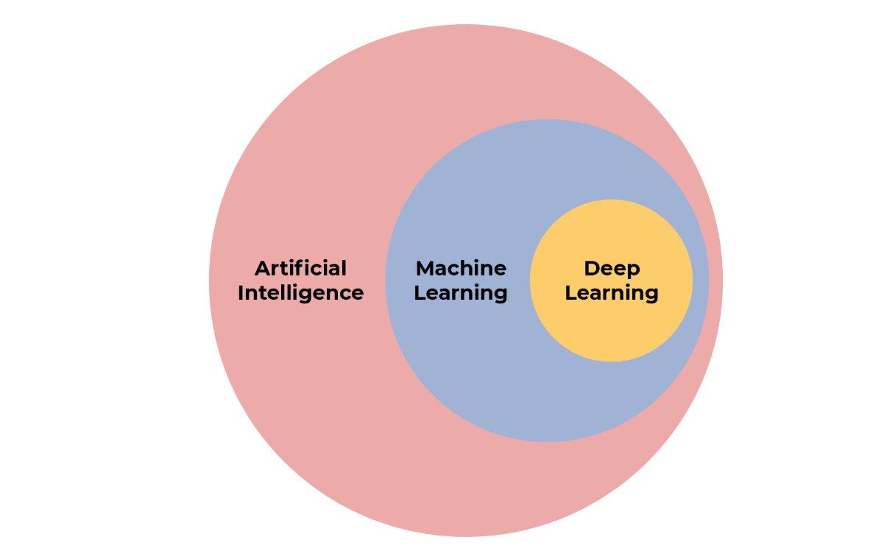

Task 1: Study the Basic Architecture of FNN, CNN, and RNN
- Feedforward Neural Network (FNN): it is the simplest type of artificial neural network. It consists of an input layer, one or more hidden layers, and an output layer. Every neuron in one layer is connected to every neuron in the next layer (a "fully connected" or "dense" structure). Data moves strictly forward from input to hidden layers to output and there are no cycles or loops in the connections. Each connection has a weight, and each neuron applies an activation function (such as ReLU or Sigmoid) to the weighted sum of its inputs before passing the result to the next layer. Training adjusts these weights using backpropagation, gradually reducing the difference between the network's predictions and the actual target values.

Structural Components & Mathematical Formulation
  - Input Layer: Takes the input features as a vector, e.g., x = [x₁, x₂, ..., xₙ].
  - Hidden Layers: Made of fully connected neurons. Each neuron receives input from all neurons in the previous layer.
  - Weights and Biases:
    - Weight (W): Controls the importance of each input.
    - Bias (b): Helps adjust the output.
    - Basic calculation: z = W × x + b
  - Activation Function: Adds non-linearity so the network can learn complex patterns.
    - ReLU: Commonly used in hidden layers.
    - Sigmoid: Used mainly for binary classification.
    - Softmax: Used for multi-class classification.
  - Output Layer: Produces the final prediction.
    - Regression: Linear output.
    - Binary classification: Sigmoid.
    - Multi-class classification: Softmax.
  - Forward Pass
For each layer: z⁽ˡ⁾ = W⁽ˡ⁾a⁽ˡ⁻¹⁾ + b⁽ˡ⁾, a⁽ˡ⁾ = σ(z⁽ˡ⁾)

Input → Weighted Sum + Bias → Activation → Next Layer → Output
Training: The network compares the actual value (y) with the predicted value (ŷ).
- Loss function calculates the prediction error.
- Backpropagation finds how much each weight contributed to the error.
- Gradient Descent updates the weights to reduce the error.

Key Limitations of FNN
  - Destroys spatial information: Images must be flattened, so relationships between nearby pixels are lost.
  - Too many parameters: Fully connected layers need a huge number of weights for large inputs.

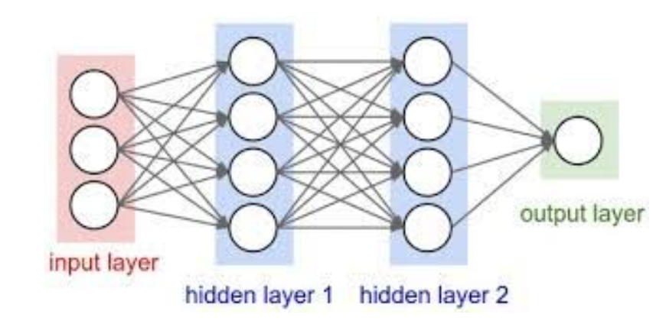
2.Convolutional Neural Network (CNN): it is a deep learning architecture specifically designed to process grid-structured data, such as images, videos, and other multi-dimensional data. CNNs were developed to overcome the limitations of Feedforward Neural Networks (FNNs) in handling spatial information.
Unlike FNNs, which connect every neuron to every input, CNNs use small filters (kernels) that move across the input data. This convolution operation detects important local features such as edges, textures, patterns, and shapes while preserving the spatial relationships between them.

Core Architectural Layers & Spatial Mechanisms
  - Convolution Layer: Uses small filters or kernels such as 3×3 or 5×5 to scan the image and detect features like edges, corners, textures, and shapes.
  - Parameter Sharing: The same filter weights are used across the entire image. This reduces the number of parameters and helps the CNN recognize the same feature in different locations.
  - ReLU Activation: Adds non-linearity to the network. It changes negative values to zero and keeps positive values.
  - Pooling Layer: Reduces the size of feature maps. Max Pooling selects the highest value from a small area such as 2×2, reducing computation while keeping important features.
  - Flattening: Converts the 2D/3D feature maps into a 1D vector.
  - Fully Connected Layer: Takes the extracted features and uses them to make the final prediction or classification.

Key structural points:
convolution uses weight sharing the same small filter scans the whole image which drastically reduces the number of parameters compared to a fully connected network.
  - pooling (max or average) makes the learned features robust to small shifts or distortions in the image.
  - early layers learn simple features (edges), while deeper layers combine them into complex features (shapes, objects).

Simple CNN Flow
Input Image → Convolution → ReLU → Max Pooling → Flatten → Fully Connected Layer → Output
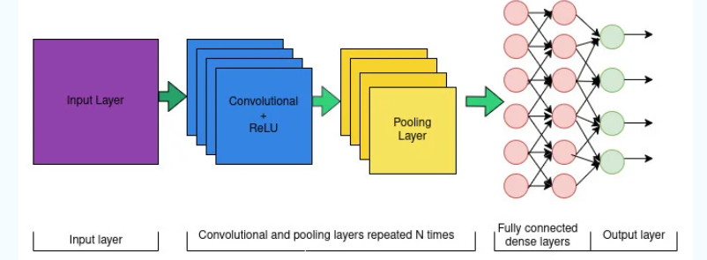

3.Recurrent Neural Network (RNN): it is built to handle sequential data, where the order of inputs matters. Unlike FNNs and CNNs, an RNN has a feedback loop: the output of the hidden layer at one time step is fed back as an additional input at the next time step. This creates a "hidden state" that acts as a memory, allowing the network to retain information about earlier elements in the sequence while processing later ones. When this loop is "unrolled" across time steps, the RNN can be visualized as a chain of repeating cells, each receiving a new input together with the hidden state carried over from the previous step.

Recurrent Hidden States & Feedback Loops
  - RNN is designed for sequential data, such as text, speech, and time-series data.
  - It has a hidden state (hₜ) that acts like a memory.
  - At each time step, the RNN receives:
    - Current input (xₜ)
    - Previous hidden state (hₜ₋₁)
  - The previous information is combined with the current input to produce the new hidden state (hₜ).
  - The hidden state is then used to generate the output (yₜ).
  - The same weights are reused at every time step, allowing the RNN to handle sequences of different lengths.

Simple RNN Flow
Current Input (xₜ) + Previous Memory (hₜ₋₁) → RNN → New Memory (hₜ) → Output (yₜ)

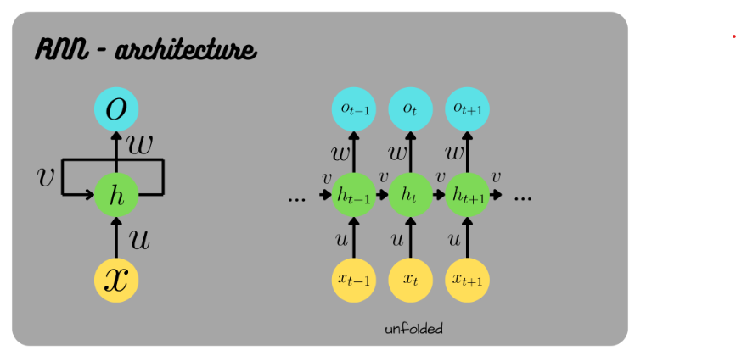

Key structural points:
  - The same weights are reused at every time step, which is what allows the network to work with sequences of varying length.
  - plain RNNs struggle to remember information from far back in a long sequence (the "vanishing gradient" problem), which led to improved variants such as LSTM (Long Short-Term Memory) and GRU (Gated Recurrent Unit) that control what information is kept or forgotten.

Task 2: Suitable Applications for Each Architecture

Applications for Feedforward Neural Networks
FNNs work best on structured, tabular data where there is no spatial or sequential relationship between input features. Common examples include:
  - Bank loan approval / credit risk scoring — predicting approval or reject from applicant income, age, credit score, and existing loans
  - House price prediction — estimating price from structured features such as area, location, and number of rooms
  - Customer churn prediction — estimating whether a subscriber will cancel a service based on usage statistics
  - Medical diagnosis support — predicting the likelihood of a condition from structured patient test results
  - Basic pattern recognition on small, fixed-size numeric inputs, such as simple sensor-reading classification

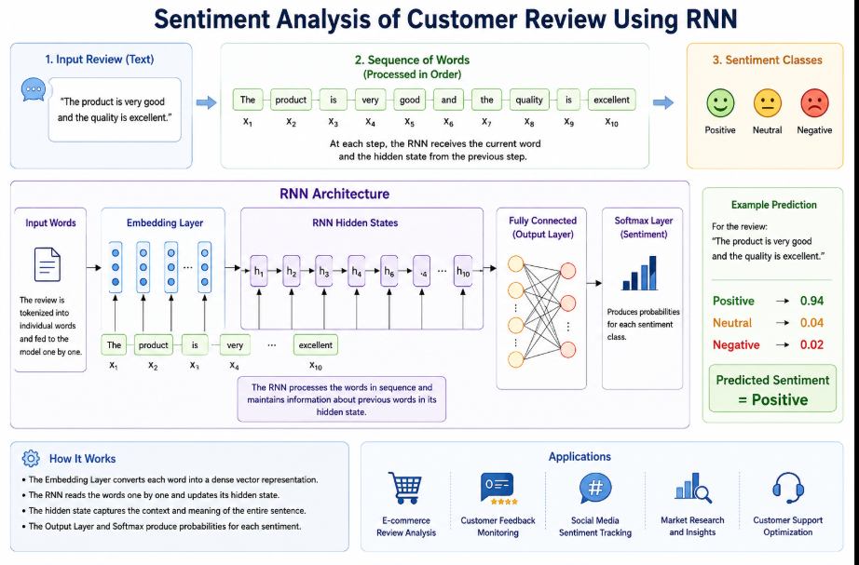

Worked Example: Customer Churn Prediction: A Feedforward Neural Network can be used to predict whether a customer is likely to leave a company (churn) or continue using its service. This is a suitable FNN application because the input consists of structured customer information rather than images or sequential data.

Case Study
  - Target Industry: Telecommunications / Banking / Subscription Services
  - Problem: Predict whether a customer will leave the service.
- → Customer stays , 1 → Customer churns
  - Input Features: Consider a customer with the following features:
    - x₁: Age = 35 years
    - x₂: Monthly Charges = ₹1,200
    - x₃: Tenure = 8 months
    - x₄: Number of Complaints = 3
    - x₅: Contract Type = Month-to-Month
These features are converted into numerical values and given to the FNN as an input vector.
  - FNN Architecture: Input Layer → Dense Layer (128 neurons, ReLU) → Dense Layer (64 neurons, ReLU) → Output Layer (1 neuron, Sigmoid)
  - The first hidden layer learns relationships between customer features.
  - The second hidden layer learns more complex patterns, such as high charges + short tenure + frequent complaints.
  - The Sigmoid output layer produces a probability between 0 and 1.

Example Prediction
Suppose the network produces:
Output = 0.87 This means the model estimates an 87% probability of customer churn. If the decision threshold is 0.5:
0.87 > 0.5 → Churn (1)
Therefore, the company can identify this customer as high-risk and take actions such as offering discounts, better plans, or customer support.
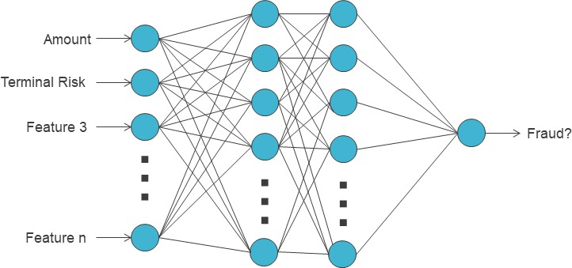

Applications for Convolutional Neural Networks
CNNs are the preferred choice whenever the input has a spatial structure, most commonly images and video. Common examples include:
- Handwritten digit / character recognition — e.g. reading postal codes or bank cheque amounts
- Image classification — e.g. identifying whether a photo contains a cat or a dog

- Object detection — e.g. detecting pedestrians and vehicles for self-driving cars
- Facial recognition used in smartphone unlocking and security/surveillance systems
- Medical image analysis — e.g. detecting tumors in X-ray, CT, or MRI scans
Worked Example: Traffic Sign Recognition: A Convolutional Neural Network (CNN) can be used to automatically recognize and classify traffic signs from road
images. This is a suitable CNN application because traffic signs are visual objects with important spatial features such as shapes, colours, edges, and patterns.

Case Study

Customer Review Sentiment Analysis

Target Domain: E-commerce and Customer Feedback Analysis

Problem:
Determine whether a customer review expresses a Positive, Negative, or Neutral sentiment using a Recurrent Neural Network (RNN).

Example Classes:
Positive, Negative, Neutral.

Input Data:
The RNN receives a customer review as text. Since a review consists of a sequence of words, the words are processed in their original order.

For example:

“The product is very good and the quality is excellent.”

The sentence can be divided into individual words:

The → product → is → very → good → and → the → quality → is → excellent

At each step, the RNN receives the current word along with the hidden state generated from the previous word. This allows the network to retain information about earlier words while processing the sentence.

RNN Architecture:
Input Text → Tokenization → Embedding Layer → RNN Hidden States → Fully Connected Layer → Softmax → Sentiment

How It Works:
The embedding layer converts words into numerical vectors. The RNN processes these vectors sequentially and maintains a hidden state containing information from previous words. This helps the model understand the context and sequence of the review. Finally, the Softmax layer calculates the probability of each sentiment class.

Example Prediction:
For the review:

“The product is very good and the quality is excellent.”

The RNN may produce:

Positive → 0.94

Neutral → 0.04

Negative → 0.02

The highest probability is 0.94 for Positive.

Therefore:
Predicted Sentiment = Positive

Application:
This system can be used by e-commerce companies to automatically analyze large numbers of customer reviews, identify customer satisfaction levels, and understand opinions about their products and services.

Applications for Recurrent Neural Networks
RNNs are suited to problems where data arrives as a sequence and past context influences the present output. Common examples include:
  - Language modelling and text generation / next-word prediction, such as smartphone keyboard suggestions
  - Speech recognition — converting spoken audio, which unfolds over time, into text
  - Machine translation — translating a sentence from one language to another
  - Sentiment analysis of a sentence or review, where meaning depends on word order
  - Stock price and other time-series forecasting, where past values influence future values

Case Study
  - Target Domain: E-commerce and Customer Feedback Analysis
  - Problem: Determine whether a customer review is Positive, Negative, or Neutral.
  - Input Data: Consider the customer review:
    - “Overall, I enjoyed the movie a lot.”
    - The sentence is divided into individual words and processed sequentially: Overall → I → enjoyed → the → movie → a → lot
    - At each step, the RNN receives the current word and the hidden state from the previous work.
  - RNN Architecture: Input Words → Embedding Layer → RNN Hidden States
→ Output Layer → Sentiment.
  - Example Prediction: For the review: "The product is very good and the quality is excellent." The model may produce:
Positive → 0.94, Neutral → 0.04, Negative → 0.02
Therefore: Predicted Sentiment = Positive

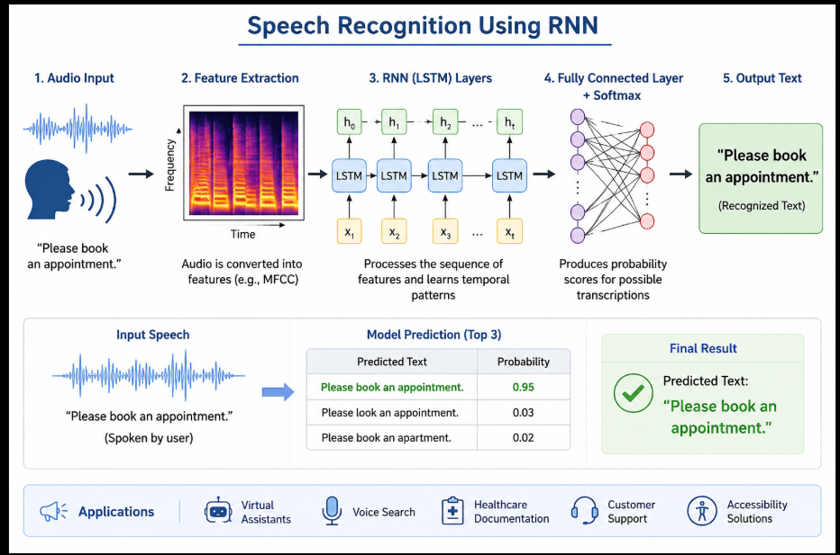

Task 3: Comparison of the Three Architectures

Aspect | Feedforward Neural Network (FNN) | Convolutional Neural Network  (CNN) | Recurrent Neural Network (RNN)
Basic Structure | Neurons arranged in fully connected layers; signal moves in a single  forward direction | Layers of convolution and pooling filters followed by fully  connected layers | Neurons with feedback loops; the hidden state is passed from one step to the next
Direction of Data Flow | One-directional (input to output only) | One-directional, but spatial filters slide over the input | Cyclical / sequential; output of a step feeds back as input to the next step
Type of Input Data | Fixed-size numeric or tabular data (structured  data) | Grid-like data such as images, video frames | Sequential data such as text, speech, or time-series
Memory of Past Inputs | None | None (each input is processed  independently) | Yes, retains context from earlier steps through hidden state
Key Mechanism | Weighted sums and activation functions | Convolution and pooling operations for  feature extraction | Recurrent connections that carry information across time
Typical Applications | Prediction, classification of tabular data (e.g. loan  approval) | Image classification, object detection, facial  recognition | Language modelling, speech recognition, stock price  prediction
Strength | Simple and fast for structured data | Excellent at capturing spatial patterns | Excellent at capturing temporal/sequential patterns
Limitation | Cannot handle spatial or sequential patterns well | Not designed for sequential/time-dependent data | Can be slow to train; struggles with very long sequences (addressed by LSTM/GRU)
Everyday Example (from this report) | Email spam detection from structured features  / loan approval  prediction | Classifying a photo as 'Cat' or 'Dog' | Predicting the next word while typing on a keyboard
Well-Known Real-World Systems | Credit-scoring apps, insurance-premium calculators | Google Photos, Face ID, self-driving car vision systems | Google Translate, voice assistants like Siri/Alexa, stock-forecast apps

Conclusion: FNN, CNN, and RNN are designed for different types of data FNN is Best for structured/tabular data such as fraud detection and loan approval. CNN is Best for images and spatial data by detecting patterns such as edges, shapes, and textures. RNN is Best for sequential data such as text, speech, and time-series data by using memory of previous inputs. No architecture is always better than the others. The right neural network depends on the type and structure of the input data.

